**Australian Islamic College 2020**

**ATAR Chemistry Units 3 and 4**

**Task 10 (Weighting: 5%)**

**Esters Validation Test**

Test Time: 45 minutes

Please do not turn this page until instructed to do so.

|  |  |
| --- | --- |
| **First Name** | **Surname** |
|  |  |

|  |
| --- |
| **Teacher** |
|  |

|  |  |
| --- | --- |
| **Mark / 49** | **Percentage** |
|  |  |

Equipment allowed: Pens, pencils, erasers, whiteout, correction tape, rulers and non-programmable calculators permitted by the Schools Curriculum and Standards Authority.

**Special conditions**:

2 marks will be deducted for failing to write your full name on this test paper.

**Teacher help**: Your teacher can only help you during your test in one situation.

If you believe there is a mistake in a question show your teacher and your teacher will tell you if there is a mistake in the question and if appropriate, how to fix that mistake.

**Spelling of Science words** must be correct. Science words with more than one letter wrong (wrong letter and/or wrong place) will be marked wrong.

**Equations** must be written balanced and with correct state symbols or they will be marked wrong.

Questions must be answered in this booklet.

Total marks: 49

**PART ONE: MULTIPLE CHOICE QUESTIONS (4 MARKS)**

**Circle the correct answer on this page.**

1. Which of these is not a structural isomer of propyl ethanoate?
   1. Butyl methanoate
   2. Ethyl propanoate
   3. Methyl propanoate
   4. Methyl butanoate
2. Butyl propanoate will result from the esterification reaction between which pair of molecules?
   1. Butane and propanoic acid
   2. Butanoic acid and propan-1-ol
   3. Propanoic acid and butan-2-ol
   4. Propanoic acid and butan-1-ol
3. The inorganic substance resulting from the esterification reaction between methanoic acid and ethanol is which of these?
   1. Methyl ethanoate
   2. Ethyl propanoate
   3. Ethyl ethanoate
   4. Water
4. An esterification reaction between which two substances will produce 1-methylpropylpentanoate?
   1. 1-methylpropanol and pentanoic acid
   2. Propan-1-ol and pentanoic acid
   3. Pentan-1-ol and propanoic acid
   4. Butan-2-ol and pentanoic acid

**END OF MULTIPLE CHOICE SECTION**

**PART TWO: SHORT ANSWER QUESTIONS (45 marks)**

1. Draw the full structure, including all bonds and all hydrogen atoms, and name, the ester with the lowest relative molecular mass.

[2 marks]

1. Draw a full structural diagram of ethyl ethanoate, including all bonds and all atoms. Include in your diagram all lone pair electrons.

[2 marks]

1. Esters have highly electronegative oxygen atoms. They also have hydrogen atoms. Despite this, hydrogen bonding does not occur between ester molecules. Explain why not.

[1 mark]

1. Despite not being able to hydrogen bond to each other, esters can hydrogen bond with water. Draw a diagram to show hydrogen bonding between water and the carbonyl oxygen in methyl ethanoate. Use a dashed line to indicate the hydrogen bond. Use “delta plus” and “delta minus” symbols to indicate the partial positive and negative charges on the atoms involved in forming the hydrogen bond.

[3 marks]

1. Below is information about four substances. You may assume that there is no significant difference between the relative molecular masses of the substances.

|  |  |  |  |
| --- | --- | --- | --- |
| **Condensed Structural Formula** | **IUPAC Name** | **Relative Molecular Mass** | **Boiling Point (oC)** |
| CHO2CH3 |  | 60 |  |
| CH3CH2CH2CH3 |  | 58 |  |
| CH3CH2CH2OH |  | 60 |  |
| CH3COOH |  | 60 |  |

The boiling points of the four substances in random order at -1 oC, 32 oC, 97 oC and 118 oC.

* 1. Complete the second column by naming the molecules shown in the first column.

[2 marks; ½ each]

* 1. Complete the last column of the table by inserting the boiling points corresponding to each substance.

[3 marks maximum; Number of marks = number correct subtract one]

* 1. List in order of decreasing strength ALL the intermolecular forces present between molecules of these substances.
     1. CH3COOH

[1 mark; no half marks]

* + 1. CHO2CH3

[1 mark; no half marks]

* 1. Explain the difference between the boiling points of CH3CH2CH2CH3 and CHO2CH3 by referring to specific structures in each molecule and the resulting intermolecular forces.

[8 marks]

1. The following questions refer to the video ‘Making Esters’.
   1. What was the catalyst?

[1 mark]

* 1. How did the catalyst increase reaction rate?

[2 marks]

* 1. Esters were described as ‘volatile’. Suggest why they are more volatile than water by referring to specific structures within these molecules.

[5 marks]

* 1. Name and explain the purpose of the method used to smell the esters that were made in this video.

[3 marks]

* 1. Name a safety hazard in ester production and a safety precaution against that hazard.

[2 marks]

* 1. State observations for the synthesis of ethyl ethanoate.

[4 marks]

1. Shown below are the two molecules shown being made in the video. These are labelled below are molecules A and B.

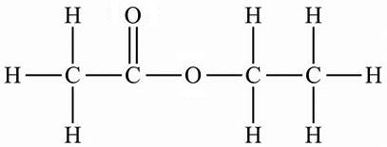 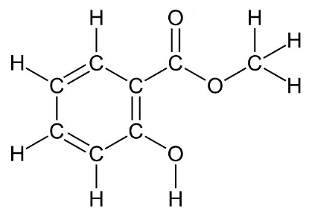

A B

State which molecule, A or B, will be more soluble in water. Explain why.

[5 marks]

**END OF TEST**

**Blank Page For Student Use. This Page Will Not Be Marked.**